**Chapter 8, Problem 1**

Define (*a*) a phase in a material and (*b*) a phase diagram.

**Chapter 8, Solution 1**

1. A phase in a material is a microscopic region that differs in structure and/or composition from another region.
2. A phase diagram is a graphical representation of the phases present within a materials system for a range of temperatures, pressures and compositions.

**Chapter 8, Problem 2**

In the pure water pressure-temperature equilibrium phase diagram (Fig. 8.1) what phases are in equilibrium for the following conditions: (a) along the freezing line, (b) along the vaporization line, and

1. at the triple point.

**Chapter 8, Solution 2**

1. Along the freezing line, liquid and solid phases are in equilibrium.
2. Along the vaporization line, liquid and vapor phases exist in equilibrium.
3. At the triple point, all three phase – vapor, liquid and solid – coexist.

**Chapter 8, Problem 3**

How many triple points are there in the pure iron pressure-temperature equilibrium phase diagram of Fig. 8.2? What phases are in equilibrium at each of the triple points?

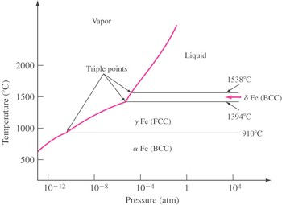

Figure 8.2

**Chapter 8, Solution 3**

Three triple points can be identified having the following phases in equilibrium:

* 1. vapor, liquid and *δ* Fe
  2. vapor, *δ* Fe, and *γ* Fe
  3. vapor, *γ* Fe, *α* Fe

**Chapter 8, Problem 4**

Write the equation for Gibbs phase rule and define each of the terms.

**Chapter 8, Solution 4**

The equation for the Gibbs phase rule is:

*P* + *F* = *C* +2

where *P* = the number of phases that coexist within a specific system

*F* = the degrees of freedom for the system

*C* = the number of components in the system

**Chapter 8, Problem 5**

Refer to the pressure-temperature equilibrium phase diagram for pure water (Fig. 8.1) and answer the following:

1. How many degrees of freedom are there at the triple point?
2. How many degrees of freedom are there along the freezing line?

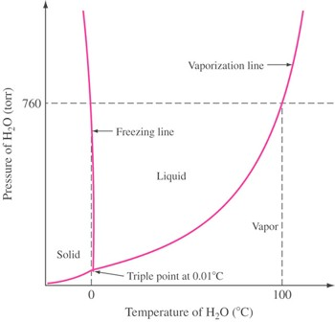

Figure 8.1

**Chapter 8, Solution 5**

1. At the triple point, there are zero degrees of freedom.
2. Along the freezing line of pure water, there is one degree of freedom.

**Chapter 8, Problem 6**

(a) What is a cooling curve? (b) What type of information may be extracted from a cooling curve? (c) Draw a schematic of a cooling curve for a pure metal and one for an alloy. Discuss the differences.

**Chapter 8, Solution 6**

1. A cooling is a record of temperature versus time for a metal as it solidifies from melt and cools to room temperature. (b) The cooling curve can provide information regarding phase changes (liquid-solid and solid-solid) experienced by the material. It can also provide information related to casting of a molten metal such as time required for solidification.

**Chapter 8, Problem 7**

What is a binary isomorphous alloy system?

**Chapter 8, Solution 7**

The binary isomorphous alloy system is a two-component system in which the two elements are completely soluble in each other in the liquid and solid states and form a single type of crystal structure for all compositions.

**Chapter 8, Problem 8**

What are the four Hume-Rothery rules for the solid solubility of one element in another?

**Chapter 8, Solution 8**

The four Hum-Rothery rules for the solid solubility of one element in another are:

* 1. The crystal structure of each element of the solid solution must be the same.
  2. The size of the atoms of each of the two elements must not differ by more than fifteen percent.
  3. The elements should not form compounds with each other; there should be no appreciable difference in the electronegativities of the two elements.
  4. The elements should have the same electron valence.

**Chapter 8, Problem 9**

Describe how the liquidus and solidus of a binary isomorphous phase diagram can be determined experimentally.

**Chapter 8, Solution 9**

The liquidus and solidus of a binary isomorphous phase diagrams can be determined experimentally by measuring cooling rate for several specific alloy compositions and plotting the corresponding liquid-solid curves. The phase diagram can then be constructed by plotting the liquidus and solidus temperatures versus composition of the alloys.

**Chapter 8, Problem 10**

Explain how a cored structure is produced in a 70% Cu-30% Ni alloy.

**Chapter 8, Solution 10**

A cored structure is produced in a 70% Cu-30% Ni alloy when the alloy is cooled rapidly; without sufficient time for complete solid-state diffusion, concentration gradients remain in the alloy structure.

**Chapter 8, Problem 11**

How can the cored structure in a 70% Cu–30% Ni alloy be eliminated by heat treatment?

**Chapter 8, Solution 11**

The cored structure can be eliminated in ingots and castings by heat treating at elevated temperatures. This homogenization process accelerates the required solid-state diffusion and thus produces a homogeneous structure in the alloy.

**Chapter 8, Problem 12**

Explain what is meant by the term *liquation*. How can a liquated structure be produced in an alloy? How can it be avoided?

**Chapter 8, Solution 12**

Liquation is the localized melting which occurs if an alloy is heated to a temperature greater than the lowest melting temperature of the alloy’s constituents. The result of such overheating is a liquated structure, in which grain boundaries may be melted. To avoid liquation, the heat treatment should be performed such that the melting temperature is approached slowly but never exceeded.

**Chapter 8, Problem 13**

Describe the mechanism that produces the phenomenon of *surrounding* in a peritectic alloy which is rapidly solidified through the peritectic reaction.

**Chapter 8, Solution 13**

Surrounding in a rapidly solidified peritectic alloy is a nonequilibrium phenomenon in which the alpha phase is encased by the beta phase during the peritectic reaction. As a result, the solid beta phase acts as a barrier to alpha diffusion and the peritectic reaction rate decreases continuously.

**Chapter 8, Problem 14**

Can coring and surrounding occur in a peritectic-type alloy which is rapidly solidified? Explain.

**Chapter 8, Solution 14**

In a rapidly solidified peritectic alloy, coring can occur during the formation of the primary alpha phase and subsequently, the cored alpha phase can be surrounded by the beta phase during the peritectic reaction.

**Chapter 8, Problem 15**

What is a monotectic invariant reaction? How is the monotectic reaction in the copper-lead system important industrially?

**Chapter 8, Solution 15**

A monotectic invariant reaction is one in which a liquid phase reacts isothermally to form a solid phase and a new liquid phase. The monotectic reaction is important industrially to the copper-lead system

because it can produce a nearly pure lead phase in copper-zinc brasses which improves the machining properties of the alloys; the lead sufficiently reduces the ductility of the alloys to cause machined chips to naturally break away from the workpiece.

**Chapter 8, Problem 16**

Write equations for the following invariant reactions: eutectic, eutectoid, peritectic, and peritectoid. How many degrees of freedom exist at invariant reaction points in binary phase diagrams?

**Chapter 8, Solution 16**

Eutectic Reaction:

*L* cooling

** + **

Eutectoid Reaction:

** cooling

**  **

Peritectic Reaction:

**  *L*

cooling **

Peritectoid Reaction:

**  **

cooling **

There are zero degrees of freedom at the invariant reaction points in binary phase diagrams.

**Chapter 8, Problem 17**

How are eutectic and eutectoid reactions similar? What is the significance of the -*oid* suffix?

**Chapter 8, Solution 17**

The eutectic and eutectoid reactions are similar in that they both involve the decomposition of a single phase into two solid phases. The –*oid* suffix indicates that a solid, rather than liquid, phase is decomposing.

**Chapter 8, Problem 18**

Distinguish between (*a*) a terminal phase and (*b*) an intermediate phase.

**Chapter 8, Solution 18**

A terminal solid solution phase occurs at the end of a phase diagram, bordering on pure components. Whereas, an intermediate solid solution phase occurs within a composition range inside the phase diagram and is separated from other phases in a binary diagram by two-phase regions.

**Chapter 8, Problem 19**

Distinguish between (*a*) an intermediate phase and (*b*) an intermediate compound.

**Chapter 8, Solution 19**

Intermediate phases, which may occur in binary metal or ceramic phase diagrams, represent a range of solid solution compositions. Conversely, an intermediate compound has a fixed composition and definite stoichiometry at room temperature and is formed between two metals or a metal and a nonmetal.

**Chapter 8, Problem 20**

What is the difference between a congruently melting compound and an incongruently melting one?

**Chapter 8, Solution 20**

A congruently melting compound maintains its composition right up to its melting point. Whereas an incongruently melting compound undergoes peritectic decomposition upon heating; the solid compound decomposes into a liquid and another solid solution.

**Chapter 8, Problem 21**

Consider an alloy containing 70 wt % Ni and 30 wt % Cu (see Fig. 8.5).

1. At 1350C make a phase analysis assuming equilibrium conditions. In the phase analysis include the following:
   1. What phases are present?
   2. What is the chemical composition of each phase?
   3. What amount of each phase is present?
2. Make a similar phase analysis at 1500°C.
3. Sketch the microstructure of the alloy at each of these temperatures by using circular microscopic fields.

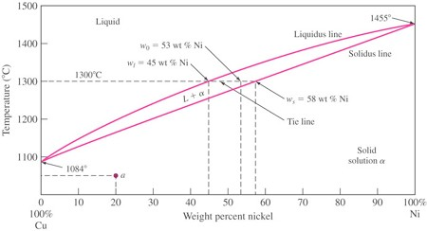

Figure 8.5

**Chapter 8, Solution 21**

(a)

* 1. The phases present are the liquid and solid (*L* + *α*).
  2. The chemical composition of liquid is *wl* = 62 wt % Ni while that of the solid is *ws* = 74 wt % Ni.
  3. The weight percent of solid and liquid are:

### Wt % of liquid phase  74  70 100%  **33.3%**

74  62

Wt % of solid phase  70  62 100%  **66.67%**

74  62

1. At 1500ºC, the alloy is 100% liquid.
2. The microstructure of the alloy at these temperatures would look similar to the following sketches.

Solid

α

Liquid

100%

1350º 1500ºC

**Chapter 8, Problem 22**

Consider the binary eutectic copper-silver phase diagram in Fig. 8.22. Make phase analyses of an 88 wt

% Ag–12 wt % Cu alloy at the temperatures

(a) 1000°C, (*b*) 800°C, (*c*) 780°C + Δ*T* , and (*d*) 780°C - Δ*T* . In the phase analyses, include:

1. The phases present
2. The chemical compositions of the phases
3. The amounts of each phase
4. Sketch the microstructure by using 2 cm diameter circular fields.

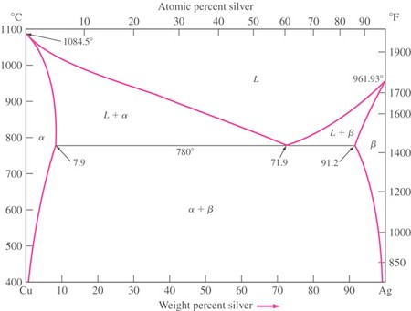

Figure 8.22

**Chapter 8, Solution 22**

|  |  |  |
| --- | --- | --- |
| (a) | At 1000ºC:  Phases present: Compositions of phases: | liquid 100% |
| (b) | At 800ºC, |  |
|  | Phases present: Compositions of phases: Amounts of phases: | liquid beta  78% Ag in liquid phase 93% Ag in *β* phase |

#### Wt % liquid phase  93  88 100%  **33.3%**

93  78

Wt % beta phase  88  78 100%  **66.6%**

93  78

1. At 780oC + T,

Phases present: liquid beta

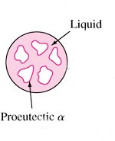Compositions of phases: 71.9% Ag in liquid phase 91.2% Ag in *β* phase Amounts of phases:

#### Wt % liquid phase 

91.2  88

91.2  71.9

100%  **16.6%**

#### Wt % beta phase 

88  71.9

91.2  71.9

100%  **83.4%**

1. At 780o C

###  T,

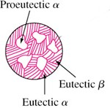Phases present: alpha beta Compositions of phases: 7.9% Ag in *α* phase 91.2% Ag in *β* phase Amounts of phases:

#### Wt % alpha phase 

91.2  88 100%  **3.84%**

#### 91.2  7.9

Wt % beta phase 

88  7.9

91.2  7.9

100%  **96.16%**

**Chapter 8, Problem 23**

If 500 g of a 40 wt % Ag–60 wt % Cu alloy is slowly cooled from 1000°C to just below 780°C (see Fig. 8.22):

1. How many grams of liquid and proeutectic alpha are present at 850°C?
2. How many grams of liquid and proeutectic alpha are present at 780°C + *T* ?
3. How many grams of alpha are present in the eutectic structure at 780°C - *T* ?
4. How many grams of beta are present in the eutectic structure at 780°C - *T* ?



Figure 8.22

**Chapter 8, Solution 23**

1. At 850ºC,

### Wt % liquid  40  7.9 100%  72.8% 52  7.9

Wt % proeutectic **  52  40 100%  27.2%

52  7.9

Weight of liquid phase  500 g  0.728  **364 g**

Weight of proeutectic **  500 g  0.272  **136 g**

1. In the eutectic structure at 780oC + T,

### Wt % liquid 

40  7.9

71.9  7.9

100%  50.2%

Wt % proeutectic **  71.9  40 100%  49.8%

71.9  7.9

Weight of liquid phase  500 g  0.502  **251 g**

Weight of proeutectic **  500 g  0.498  **249 g**

1. In the eutectic structure at 780o C

* T, the number of grams of *α* present is,

### Wt % total **  91.2  40 100%  61.5% 91.2  7.9

Weight of total **  500 g  0.615  **307.5 g**

1. In the eutectic structure at 780o C

* T, the number of grams of *β* present is,

### Wt % total ** 

40  7.9

91.2  7.9

100%  38.5%

Weight of **  500 g  0.385  **192.5 g**

**Chapter 8, Problem 24**

A lead-tin (Pb-Sn) alloy consists of 60 wt % proeutectic ** and 60 wt % eutectic ** + ** at 183°C - *T* . Calculate the average composition of this alloy (see Fig. 8.12).

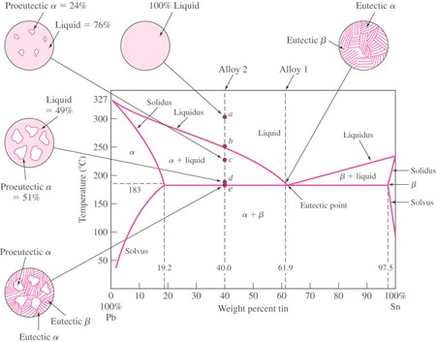

Figure 8.12

**Chapter 8, Solution 24**

Since the alloy contains 60 wt % proeutectic *β,* the wt % Sn must lie between 61.9 wt % and 97.5 wt %:

### % proeutectic ** 

*x*  61.9

### 97.5  61.9

 0.60

*x*  0.6(35.6)  61.9  83.3%

Thus, the alloy consists of **83.3 % Sn and 16.7 % Pb**.

**Chapter 8, Problem 25**

A Pb-Sn alloy (Fig. 8.12) contains 40 wt % ** and 60 wt % ** at 50°C. What is the average composition of Pb and Sn in this alloy?



Figure 8.12

**Chapter 8, Solution 25**

At 50ºC, the phase compositions are 100% Sn for *β* and approximately 2% Sn for *α*. Thus,

% ** 

### 100.0  *x*

100.0  2.0

 0.60,

*x*  100  0.6(98.0)  41.2%

The alloy consists of **41.2 % Sn and 58.8 % Pb**.

**Chapter 8, Problem 26**

An alloy of 30 wt % Pb and 70 wt % Sn is slowly cooled from 250°C to 27°C (see Fig. 8.12).

1. Is this alloy hypoeutectic or hypereutectic?
2. What is the composition of the first solid to form?
3. What are the amounts and compositions of each phase that is present at 183°C + *T* ?
4. What is the amount and composition of each phase that is present at 183°C - *T* ?
5. What are the amounts of each phase present at room temperature?



Figure 8.12

**Chapter 8, Solution 26**

1. This alloy is hypereutectoid; the composition lies to the right of the eutectic point.
2. The first solid to form is solid solution *β* containing approximately 98 % Sn.
3. At 183∫ C  *T* , the compositions of the phases present are 61.9% Sn in liquid phase and 19.2% Sn in beta phase. The amounts of the respective phases present are:

#### Wt % liquid 

97.5  70

97.5  61.9

100%  **77.2%**

#### Wt % beta 

70  61.9

97.5  61.9

100%  **22.8%**

1. At 183∫ C  *T* , the compositions of the phases present are 19.2 % Sn in *α* phase and 97.5 % Sn in *β*

phase. The amounts of the respective phases present are:

#### Wt % total ** 

97.5  70

97.5 19.2

100%  **35.1%**

#### Wt % total beta 

70 19.2

97.5 19.2

100%  **64.8%**

1. As the alloy is cooled below the eutectic temperature, the tin content in the alpha phase and the lead content in the beta phase are further reduced. However, at room temperature (20ºC), equilibrium is not achieved because the diffusion rate is so slow. Referring to Fig. 8.13, if the solvus line is extrapolated to 20ºC, the approximate composition of alpha and beta are 2.0% and 100.0 %, respectively. Thus,

#### Wt % total **  100  70 100%  **30.6%**

100  2

Wt % total beta 

70  2 100%  **69.4%**

#### 100  2

**Chapter 8, Problem 27**

Consider the binary peritectic iridium-osmium phase diagram of Fig. P8.27. Make phase analyses of a 70 wt % Ir–30 wt % Os at the temperatures

1. 2600°C, (*b*) 2665C + *T* , and (*c*) 2665C - *T* . In the phase analyses include:
   1. The phases present
   2. The chemical compositions of the phases
   3. The amounts of each phase
   4. Sketch the microstructure by using 2 cm diameter circular fields.

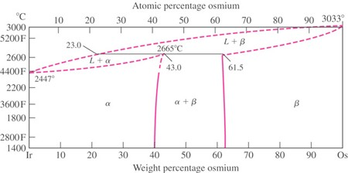

Figure 8.27

**Chapter 8, Solution 27**

(a) At 2600ºC,

1. Phases Present: Liquid and alpha phases
2. Compositions of Phases: 16% Os in liquid phase; 38% Os in alpha phase
3. Amounts of phases:

#### Wt % alpha  30 16 100%  **63.6%**

38 16

Wt % liquid  38  30 100%  **36.4%**

38 16

Solid *α*

phase



Liquid phase *L*

1. At 2665o C  *T* ,
   1. Phases Present: Liquid and beta phases
   2. Compositions of Phases: 23% Os in liquid phase; 61.5% Os in β phase
   3. Amounts of phases:

#### Wt % beta  30  23 100%  **18.2%**

61.5  23

Wt % liquid  61.5  30 100%  **81.8%**

61.5  23

Solid *β*

phase



Liquid phase *L*

1. At 2665o C  *T* ,
   1. Phases Present: Liquid and alpha phases
   2. Compositions of Phases: 23% Os in liquid phase; 43% Os in *α* phase
   3. Amounts of phases:

#### Wt % alpha  30  23 100%  **35.0%**

43  23

Wt % liquid  43  30 100%  **65.0%**

43  23

Solid α phase

Liquid phase L



**Chapter 8, Problem 28**

Consider the binary peritectic iridium-osmium phase diagram of Fig. P8.27. Make phase analyses of a 40 wt % Ir–60 wt % Os at the temperatures (*a*) 2600C, (*b*) 2665C + *T* , (*c*) 2665C - *T* , and (*d*) 2800C. Include in the phase analyses the four items listed in Prob. 8.20.

**Chapter 8, Solution 28**

(d) At 2600ºC,

|  |  |  |
| --- | --- | --- |
| (i) | Phases Present: | Alpha and beta phases |
| (ii) | Compositions of Phases: | 43% Os in alpha phase; 61.5% Os in beta phase |
| (iii) | Amounts of phases: |  |

### Wt % alpha  61.5  60 100%  **8.1%**

61.5  43

Solid α phase

### Wt % beta 

60  43

61.5  43

100%  **91.9%**

Beta phase

1. At 2665o C  *T* ,



|  |  |  |
| --- | --- | --- |
| (i) | Phases Present: | Liquid and beta phases |
| (ii) | Compositions of Phases: | 23% Os in alpha phase; 61.5% Os in beta phase |
| (iii) | Amounts of phases: |  |

### Wt % liquid phase  61.5  60 100%  **3.9%**

61.5  23

Solid β phase

### Wt % beta phase 

60  23

61.5  23

100%  **96.1%**

Liquid phase

1. At 2665o C  *T* ,



|  |  |  |
| --- | --- | --- |
| (i) | Phases Present: | Alpha and beta phases |
| (ii) | Compositions of Phases: | 43% Os in liquid phase; 61.5% Os in beta phase |
| (iii) | Amounts of phases: |  |

### Wt % alpha  61.5  60 100%  **8.1%**

61.5  43

Solid α phase

### Wt % beta 

60  43

61.5  43

100%  **91.9%**

Beta phase

(g) At 2800ºC,



* 1. Phases Present: Alpha and beta phases
  2. Compositions of Phases: 45% Os in liquid phase; 85% Os in beta phase
  3. Amounts of phases:

Solid α phase



Beta phase

### Wt % liquid  85  60 100%  **62.5%**

85  45

Wt % beta  60  45 100%  **37.5%**

85  45

**Chapter 8, Problem 29**

Consider the binary peritectic iridium-osmium phase diagram of Fig. P8.27. Make phase analyses of a 70 wt % Ir–30 wt % Os at the temperatures

1. 2600°C, (*b*) 2665C + *T* , and (*c*) 2665C - *T* . In the phase analyses include:
   1. The phases present
   2. The chemical compositions of the phases
   3. The amounts of each phase
   4. Sketch the microstructure by using 2 cm diameter circular fields.



Figure 8.27

**Chapter 8, Solution 29**

(d) At 2600ºC,

1. Phases Present: Liquid and alpha phases
2. Compositions of Phases: 16% Os in liquid phase; 38% Os in alpha phase
3. Amounts of phases:

### Wt % alpha  30 16 100%  **63.6%**

38 16

Wt % liquid  38  30 100%  **36.4%**

38 16

Solid *α*

phase



Liquid phase *L*

1. At 2665o C  *T* ,
   1. Phases Present: Liquid and beta phases
   2. Compositions of Phases: 23% Os in liquid phase; 61.5% Os in β phase
   3. Amounts of phases:

### Wt % beta  30  23 100%  **18.2%**

61.5  23

Wt % liquid  61.5  30 100%  **81.8%**

61.5  23

Solid *β*

phase



Liquid phase *L*

1. At 2665o C  *T* ,
   1. Phases Present: Liquid and alpha phases
   2. Compositions of Phases: 23% Os in liquid phase; 43% Os in *α* phase
   3. Amounts of phases:

### Wt % alpha  30  23 100%  **35.0%**

43  23

Wt % liquid  43  30 100%  **65.0%**

43  23

Solid α phase

Liquid phase L



**Chapter 8, Problem 30**

In the copper-lead (Cu-Pb) system (Fig. 8.24) for an alloy of Cu–10 wt % Pb, determine the amounts and compositions of the phases present at (*a*) 1000C, (*b*) 955C + *T* , (*c*) 955C - *T* , and (*d*) 200C.

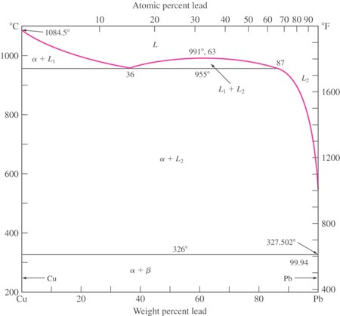

Figure 8.24

**Chapter 8, Solution 30**

In the copper-lead (Cu-Pb) system (Fig. 8.24) for an alloy of Cu-10 wt % Pb, determine the amounts and

compositions of the phases present at (a) 1000ºC (b) 955o C

 *T* , (c) 955o C

− *T* , and (d) 200ºC.

(a) At 1000ºC,

Compositions of Phases: 100% Cu, 0% Pb in *α* phase; 81% Cu, 19% Pb in *L*1 phase

Amounts of Phases:

Wt % **  19 10 100%  **47.4%**

### 19  0

Wt % *L*1

 10  0 100%  **52.6%**

### 19  0

1. At 955o C  *T* ,

Compositions of Phases: 100% Cu, 0% Pb in *α* phase; 64% Cu, 36% Pb in *L*1 phase

Amounts of Phases:

Wt % **  36 10 100%  **72.2%**

### 36  0

Wt % *L*1

 10  0 100%  **27.8%**

### 36  0

1. At 955o C  *T* ,

Compositions of Phases: 100% Cu, 0% Pb in *α* phase; 13% Cu, 87% Pb in *L*2 phase

Amounts of Phases:

Wt % **  87 10 100%  **88.5%**

### 87  0

Wt % *L*2

 10  0 100%  **11.5%**

### 87  0

1. At 200ºC,

Compositions of Phases: 99.995% Cu, 0.005% Pb in *α* phase; 0.007% Cu, 99.993% Pb in *β* phase

Amounts of Phases:

### Wt % **  99.99 10 100%  **90%**

99.99  0

Wt % ** 

### 10  0

99.99  0

100%  **10%**

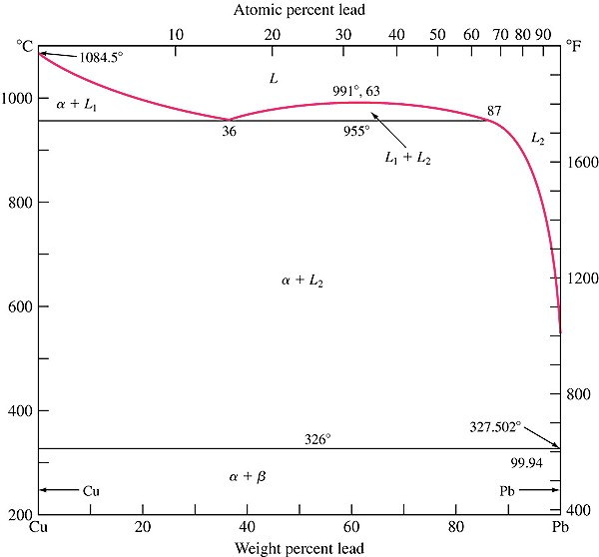

Figure 8.24 The copper-lead phase diagram.

**Chapter 8, Problem 31**

For an alloy of Cu–70 wt % Pb (Fig. 8.24), determine the amounts and compositions in weight percent of the phases present at (*a*) 955C + *T* , (*b*) 955C - *T* , and (*c*) 200C.



Figure 8.24

**Chapter 8, Solution 31**

1. At 955o C  *T* ,

Compositions of Phases: 64% Cu, 36% Pb in L1 phase 13% Cu, 87% Pb in L2 phase;

Amounts of Phases:

Wt % *L*2

 70  36 100%  **66.7%**

### 87  36

Wt % *L*1

 87  70 100%  **33.3%**

### 87  36

1. At 955o C  *T* ,

Compositions of Phases: 100% Cu, 0% Pb in α phase; 13% Cu, 87% Pb in L2 phase

Amounts of Phases:

Wt % **  87  70 100%  **19.5%**

### 87  0

Wt % *L*2

 70  0 100%  **80.5%**

### 87  0

1. At 200ºC,

Compositions of Phases: 99.995% Cu, 0.005% Pb in α phase; 0.007% Cu, 99.993% Pb in β phase

Amounts of Phases:

### Wt % **  99.99  70 100%  **30%**

99.99  0

Wt % ** 

### 70  0

99.99  0

100%  **70%**

**Chapter 8, Problem 32**

What is the average composition (weight percent) of a Cu-Pb alloy that contains 30 wt % *L*1 and 70 wt %

** at

955C + *T* ?

**Chapter 8, Solution 32**

For a 30 wt % *L*1 composition to exist at 955o C  *T* ,

Wt % *L*1

###  *x*  0 36  0

 0.30

*x*  10.8%

Thus, the alloy contains **10.8% Pb** and **89.2% Cu**.

**Chapter 8, Problem 33**

Consider an Fe–4.2 wt % Ni alloy (Fig. 8.17) that is slowly cooled from 1550 to 1450°C. What weight percent of the alloy solidifies by the peritectic reaction?

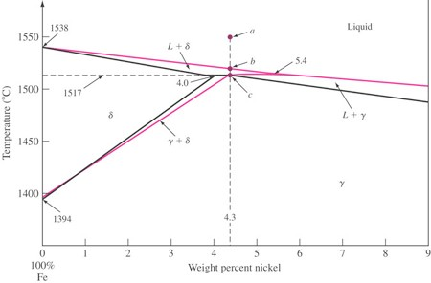

Figure 8.17

**Chapter 8, Solution 33**

Referring to Fig. 8.17, during the peritectic reaction, liquid and *δ* phases react to form solid *γ*:

Wt % **  4.2  4.0 100%  **66.7%**

### 4.3  4.0

At the end of the reaction, there is an excess of *δ* phase having a wt % of 33.3 %.

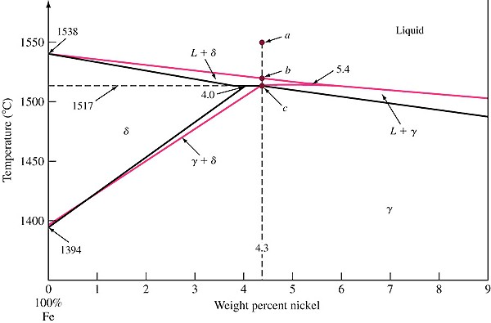

Figure 8.17 The peritectic region of the iron-nickel phase diagram. The peritectic point is located at 4.3% Ni and 1517°C, which is point c.

**Chapter 8, Problem 34**

Consider an Fe–5.0 wt % Ni alloy (Fig. 8.17) that is slowly cooled from 1550 to 1450°C. What weight percent of the alloy solidifies by the peritectic reaction?



Figure 8.17

**Chapter 8, Solution 34**

During the peritectic reaction, liquid solidifies to form solid *γ*:

Wt % **  5.4  5.0 100%  **36.4%**

### 5.4  4.3

**Chapter 8, Problem 35**

Determine the weight percent and composition in weight percent of each phase present in an Fe–4.2 wt

% Ni alloy (Fig. 8.17) at 1517C + *T* .



Figure 8.17

**Chapter 8, Solution 35**

Just above the eutectic temperature, the alloy composition is: 4.0 wt % Ni in the *δ* phase and 5.4 wt % Ni in the liquid phase. The weight percentages of these phases are:

#### Wt % liquid  4.2  4.0 100%  **14.3%**

5.4  4.0

Wt % **  5.4  4.2 100%  **85.7%**

#### 5.4  4.0

**Chapter 8, Problem 36**

Determine the composition in weight percent of the alloy in the Fe–Ni system (Fig. 8.17) that will produce a structure of 40 wt % ** and 60 wt % ** just below the peritectic temperature.



Figure 8.17

**Chapter 8, Solution 36**

For a 40 wt % *δ* composition to exist at 1517o C  *T* ,

Wt % ** 

4.3  *x*

### 4.3  4.0

 0.40

*x*  4.18%

Thus, the alloy contains **4.18% Ni** and **95.82% Fe**.

**Chapter 8, Problem 37**

Draw, schematically, the liquidus and the solidus lines for Cu-Zn diagram (Fig. 8.26). Show all the critical zinc contents and temperatures. Which one of these temperatures should be important to metal- forming processes? Why?

**Chapter 8, Solution 37**

As discussed in Chapter 5, metal forming can be performed at elevated temperatures, however the temperature should not cause melting of the material. Thus hot metal forming temperatures are below solidus temperatures. It is important to note that depending on the composition of the alloy, the hot working temperature could be significantly different. (see Figure)

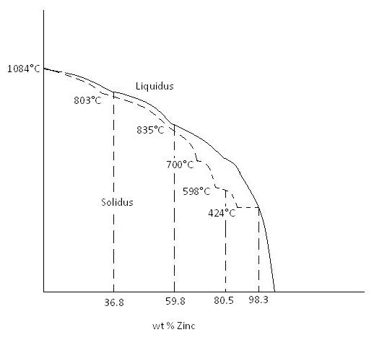

**Chapter 8, Problem 38**

Consider the Cu-Zn phase diagram of Fig. 8.26.

1. What is the maximum solid solubility in weight percent of Zn in Cu in the terminal solid solution **?
2. Identify the intermediate phases in the Cu-Zn phase diagram.
3. Identify the three-phase invariant reactions in the Cu-Zn diagram.
   1. Determine the composition and temperature coordinates of the invariant reactions.
   2. Write the equations for the invariant reactions.
   3. Name the invariant reactions.

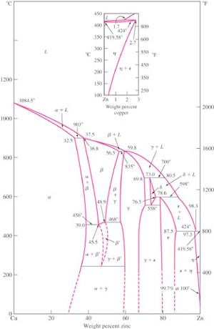

Figure 8.26

**Chapter 8, Solution 38**

1. The maximum solid solubility in weight percent of zinc in copper in the solid solution *α* is 39%.
2. The intermediate phases are *β*, *γ*, *δ*, and **.
3. The three-phase invariant reactions are:
   1. Peritectic reaction at 903ºC, 36.8% Zn

### ** (32.5% Zn) + *L*(37.5% Zn)



** (36.8% Zn)

* 1. Peritectic reaction at 835ºC, 59.8% Zn

### ** (56.5% Zn)  *L*(59.8% Zn)



** (59.8% Zn)

* 1. Peritectic reaction at 700ºC, 73% Zn

### ** (69.8% Zn)  *L*(80.5% Zn)



** (73% Zn)

* 1. Peritectic reaction at 598ºC, 78.6% Zn

### ** (76.5% Zn)  *L*(89% Zn)  Ú(78.6% Zn)

* 1. Peritectic reaction at 424ºC, 97.3% Zn

### Ú(87.5% Zn)  *L*(98.3% Zn)



### **(97.3% Zn)

* 1. Eutectoid reaction at 558ºC, 73% Zn

### ** (73% Zn)



### ** (69.8% Zn)  Ú(78.6% Zn)

* 1. Eutectoid reaction at 250ºC, 47% Zn

### ** (47% Zn)



** (37% Zn)  ** (59% Zn)

**Chapter 8, Problem 39**

Consider the aluminum-nickel (Al-Ni) phase diagram of Fig. P8.39. For this phase diagram:

1. Determine the coordinates of the composition and temperature of the invariant reactions.
2. Write the equations for the three-phase invariant reactions and name them.
3. Label the two-phase regions in the phase diagram.

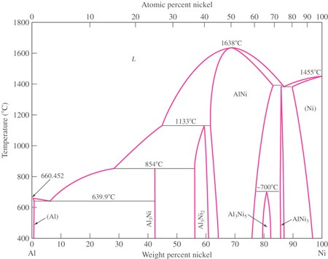

Figure 8.39

**Chapter 8, Solution 39**

1. and (b):
   1. Eutectic reaction at 639ºC, 0.1% Ni

# *L* (0.1% Ni)



# Al(0.05% Ni)  Al3Ni(42% Ni)

* 1. Peritectic reaction at 854ºC, 42% Ni

# *L* (28% Ni)  Al3Ni2(55% Ni)



Al3Ni(42% Ni)

* 1. Peritectic reaction at 1133ºC, 59% Ni

# *L* (44% Ni)  AlNi(63% Ni)



Al3Ni2 (59% Ni)

* 1. Peritectoid reaction at 700ºC, 81% Ni

# AlNi(77% Ni)  AlNi3(86% Ni)



Al3Ni5 (81% Ni)

* 1. Peritectic reaction at 1395ºC, 86% Ni

# *L* (87% Ni)  AlNi(83% Ni)



# AlNi3 (86% Ni)

* 1. Eutectic reaction at 1385ºC, 86% Ni

# *L* (87% Ni)



# Ni(90% Ni)  AlNi3 (86% Ni)

(c) The two-phase regions are identified in Fig. 8.39 below.

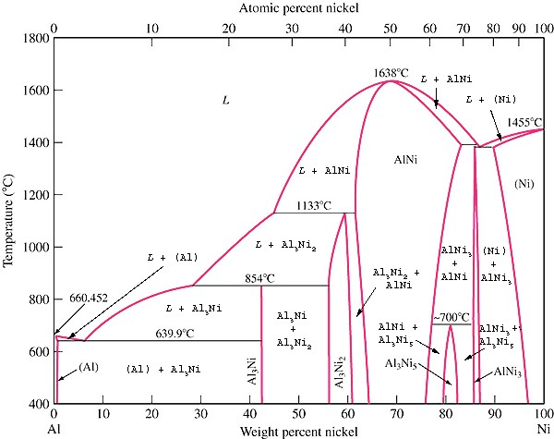

**Chapter 8, Problem 40**

Consider the nickel-vanadium (Ni-V) phase diagram of Fig. P8.40. For this phase diagram repeat questions of Prob. 8.38.

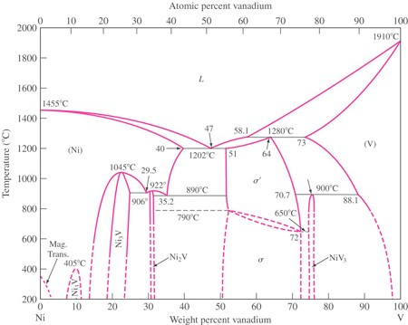

Figure 8.40

**Chapter 8, Solution 40**

(c) The two-phase regions are identified in Fig. 8.35 above.

1. and (b):
   1. Eutectoid reaction at 906ºC, 29.5% V

# Ni (29.5% V)



# Ni3V (25% V)  Ni2V(30.5% V)

* 1. Eutectoid reaction at 890ºC, 35.2% V

# Ni (35.2% V)



# Ni2V (32% V) **  (51% V)

* 1. Eutectic reaction at 1202ºC, 47.5% V

*L* (47% V)



### Ni (40% V)  **  (51% V)

* 1. Peritectic reaction at 1280ºC, 64% V

### *L* (58.1% V)  V (73% V)   **  (64% V)

* 1. Peritectoid reaction at 900ºC, 75.3% V

# **  (70.7% V)  V (88.1% V)

  NiV3 (75% V)

**Chapter 8, Problem 41**

Consider the titanium-aluminum (Ti-Al) phase diagram of Fig. P8.41. For this phase diagram, repeat questions of Prob. 8.38.

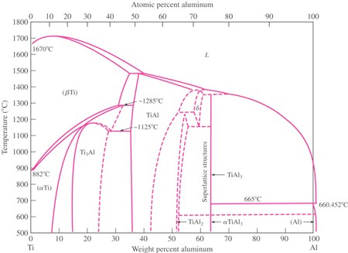

Figure 8.41

**Chapter 8, Solution 41**

(c) The two-phase regions are identified in Fig. 8.41 above.

1. and (b):
   1. Peritectoid reaction at 1285ºC, 32% Al

### ** Ti(30% Al)  TiAl(35% Al)



** Ti(32% Al)

* 1. Eutectoid reaction at 1125ºC, 27% Al

# **Ti(27% Al)



# TiAl(34% Al)  Ti3Al(26% Al)

* 1. Peritectic reaction at 1380ºC, 58% Al

### *L* (61% Al)  TiAl(56% Al)



** (58% Al)

* 1. Peritectic reaction at 1350ºC, 63% Al

# *L* (69% Al)  ** (60% Al)



# TiAl3 (63% Al)

* 1. Peritectoid reaction at 1240ºC, 55% Al

# TiAl(51% Al)  ** (57% Al)



# TiAl2 (55% Al)

* 1. Eutectoid reaction at 1150ºC, 58% Al

# ** (58% Al)



# TiAl2(55% Al)  TiAl3(63% Al)

* 1. Peritectic reaction at 665ºC, 99% Al

# *L* (100% Al)  TiAl3 (68% Al)



# Al(99% Al)

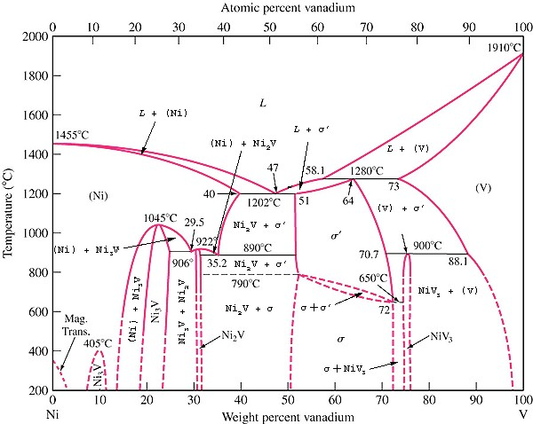

Figure 8.41 Titanium-aluminum phase diagram.

**Chapter 8, Problem 42**

What is the composition of point y in Fig. EP 8.9?

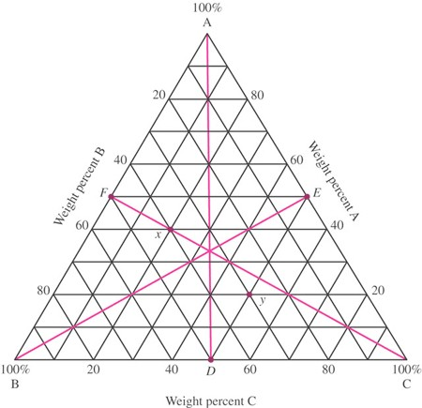

Figure EP 8.9

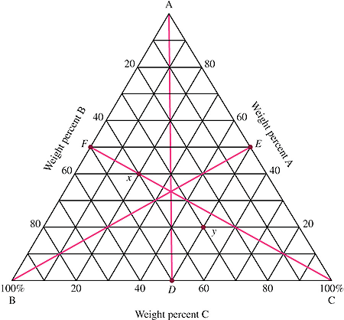

**20%**

**50%**

**30%**

nt *y* is 20% A, 30% B and 50

% C.

**Chapter 8, Solution 42**

As indicated in the ternary diagram figure below, the composition of poi

**Chapter 8, Problem 43**

In Fig. 8.12, determine the degree of freedom, F, according to Gibbs rule at the following points:

1. At the melting point of pure tin.
2. Inside the a region.
3. Inside the a _ liquid region
4. Inside the a _ b region
5. At the eutectic point

## Chapter 8, Solution 43

### Assume constant pressure @ 1 atm

⇒ P + F = C + 1

* 1. Melting point of pure tin : C=1, P=2 ⇒ F = 0 (invariant point)
  2. α region : C=2, P=1 ⇒ F = 2
  3. α + L region : C=2, P=2 ⇒ F =1
  4. α + β region : C=2, P=2 ⇒ F = -1
  5. eutectic point : C = 2, P=3 ⇒ F = 0 (invariant point)

**Chapter 8, Problem 44**

In the Pb-Sn phase diagram (Fig. 8.12) answer the following questions:

1. What is a (explain in detail including atomic structure? What is b?
2. What the maximum solubility of Sn in a? At what temperature?
3. What happens to the a in part (*b*) if it is cooled to room temperature?
4. What is the maximum solubility of Sn in liquid metal at the lowest possible temperature? What is that temperature?
5. What is the solubility limit of Sn in a when liquid is present? (This will be a range.)

**Chapter 8, Solution 44**

* 1. α is an FCC solid solution of Pb & Sn. Pb is the solvent and Sn is the solute. β is a BCT solid solution of Pb & Sn. Sn is the solvent and Pb is the solute.
  2. The maximun solubility of Sn in α is 19.2 wt % at 183°C.
  3. If the alloy in part b is cooled to below 183°C, the solubility limit of Sn in α is exceeded, and excess Sn will formβ. Thus a mixture of α & β will exist.
  4. At 183°C, a liquid solution of Pb – 61.9 wt% Sn exists. To add more Sn at this temperature, the solid phase, β, will appear (note that the question relates to a single liquid phase).

e) 0 wt % at 327°C to 61.9 wt% at 183°C.

T°C T°C

T°C T°C

84°C

84°C

0°C

## Chapter 8, Problem 45

1084°C

1084°C

102900°0C°C

780°C

### Based on the Cu – Ag phase diagra7m80°iCn Fig. P8.22, draw the approximate cooling curve for the following alloys with approximate temperatures and explanations:

* + 1. Pure Cu, (*ii*) Cu – 10wt%t Ag (*iii*) Cu – 71.9 wt% Ag (*iv*) Cu – 91.2 wt% Ag

t t

## Chapter 8, Solution 45

### Pure Cu b) Cu – 10wt% Ag



c) Cu – 71.9% wt Ag d) Cu – 91.2 wt % Ag



4T°°C

1554°TC°C

54°C

0°C

0°C

## Chapter 8, Problem 46

1554°C

1430°C

961°C

### Based on the Pd – Ag phase diagram13i9n0F°Cig. EP 8.3, draw the approximate cooling curve for the

following alloys with approximate temperatures and explanations:

1. Pure Pd, (*ii*) Pd – 30wtt% Ag (*iii*) Pd – 70 wt% Ag (*iv*) Pure Ag t

t t

## Chapter 8, Solution 46

### Pure Pd b) Pd – 30wt% Ag



c) Pd – 70% wt Ag d) Pure Ag



**Chapter 8, Problem 47**

A number of elements along with their crystal structures and atomic radii are listed in the following table. Which pairs might be expected to have complete solid solubility in each other?

**Crystal Atomic Crystal Atomic structure radius (nm) structure radius (nm)**

|  |  |  |  |  |  |
| --- | --- | --- | --- | --- | --- |
| Silver | FCC | 0.144 | Lead | FCC | 0.175 |
| Palladium | FCC | 0.137 | Tungsten | BCC | 0.137 |
| Copper | FCC | 0.128 | Rhodium | FCC | 0.134 |
| Gold | FCC | 0.144 | Platinum |  | FCC 0.138 |
| Nickel | FCC | 0.125 | Tantalum | BCC | 0.143 |
| Aluminum | FCC | 0.143 | Potassium | BCC | 0.231 |

Sodium BCC 0.185 Molybdenum BCC 0.136

**Chapter 8, Solution 47**

Pairs of these elements which may be expected to have complete solid solubility in each other are:

|  |  |  |
| --- | --- | --- |
| Silver–Palladium | Palladium–Platinum | Tantalum–Molybdenum |
| Silver–Gold | Palladium–Rhodium | Tantalum–Tungsten |
| Silver-Rhodium | Palladium–Gold | Gold–Platinum |
| Copper–Nickel | Rhodium–Platinum |  |

## Chapter 8, Problem 48

### Derive the lever rule for the amount in weight percent of each phase in two-phase regions of a binary phase diagram. Use a phase diagram in which two elements are completely soluble in each other.

**Chapter 8, Solution 48**

The lever-rule equations can be derived by first recognizing that the sum of the weight fractions of the liquid and solid phases which must equal 1.

*Xl*  *Xs*  1

Considering the weight balance of B in the alloy as a whole and the sum of B in the two phases, we arrive at:

*w*0  *Xlwl*  *Xsws*

Combining these two equations gives

*w*0  (1 *Xs* )*wl*  *Xsws*

Solving for the *Xs* gives the first lever-rule:

*w*  *w*

#### Wt fraction of solid phase  *Xs*  *o l*

*ws*  *wl*

Similarly, the second lever-rule is found to be:

*w*  *w*

#### Wt fraction of liquid phase  *Xl*  *s* 0

*ws*  *wl*

Al- 10 wt % Ni

C

## Chapter 8, Problem 49

Liquid

### Based on the Al – Ni phase diagram givenLiinquFidig+. SPo8li.d39, how many grams of Ni should be

alloyed with 100 grams of Al to synthesize an alloy of liquidus temperature of approximately 640°C?

**Chapter 8, Solution 49**

A liquidus temperature of  640°C corresponds roughly to the eutectic point indicating an overall alloy composition of  Al – 6.5 wt % Ni.

This me1a0nswtth%at if we have 100 1g8rawmt s%of Al, we need “X” grams of wNti %toNsiatisfy the following relationship:



**Chapter 8, Problem 50**

An Al-10 wt % Ni alloy, Fig. P8.39, is completely liquid at 800°C. How many grams of Ni can you add to this alloy at 800°C without creating a solid phase?

**Chapter 8, Solution 50**

At 800°C, the first evidence of solid appears when Nickel content exceeds  18 wt% (see figure below).



First solid appears at 800°C above 18 wt% Ni



Cmullite C0

CsiO2

### You add enough grams of Ni to increase the wt % from the original amount of 10 wt% to 18 wt%. If the originaClmAull-li1t0ewt%NCi0 has a mass of 100g, thenCysoiou2 may add 9.7g of Ni to the solution without forming solids.

Mullite

30 55 100

Wt %SiO2

## Chapter 8, Problem 51

### Based on the Al2O3-SiO2 phase diagram in Fig. 8.27, the wt% of phases present for Al2O3 – 55 wt% SiO2 over the 1900 to 1500°C temperature range (use 100°C increments).

**Chapter 8, Solution 51**

Al2O3 – 55 wt % SiO2 (figure 8.27)

@ 1500°C : Cmullite = 30 wt % CSiO2 = 100 wt % Co = 55 wt%

### ⇒ (100%)

 liquid (65% mullite)



°C 00°C

M + L

CM

CM C0

SiO2 + L

CL

1590°C

M@u1lli6te00°C : Cmullite = 30 wt % Cliquid = 93 wt % Co = 55 wt%

90°C

0

### liquid

30 55 100

100



CM

CM



w

Al2O3

### (60% mullite)

30 55 80

t % SiO2

@ 17 mullite = 30 wt % Cliqu Co = 55 wt%

00°C : C

id = 80 wt %

### ⇒ (100%)

 liquid (50% mullite)



@ 1800°C : Cmullite = 30 wt % Cliquid = 60 wt % Co = 55 wt%

### ⇒ (100%)

 liquid (17% mullite) figure similar to that at 1700°C

@1900°C : 100% liquid

**Chapter 8, Problem 52**

1. Design a Cu-Ni alloy that will be completely solid at 1200°C (use Fig. 8.5).
2. Design a Cu-Ni alloy that will exist at a completely molten state at 1300°C and becomes completely solid at 1200°C.

**Chapter 8, Solution 52**

* 1. To be completely solid at 1200°C, the alloy must contain at least 30 wt % Ni. (see figure below)

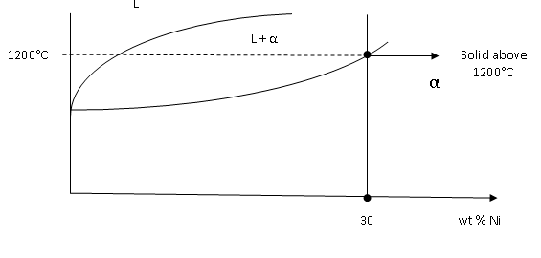

Thus any alloy ranging in composition from Cu – 30wt % Ni to 100 wt % Ni will satisfy the criterion.

0° b) Based on part (a) to be completely solid at 1200°C, Ni content must be above 30 wt %. To be completely liquid at 1300°C, the Ni content must be less than 45 wt% (see figure below).

0°



45

30

wt % Ni

### Thus, the alloy must have a composition in the range Cu – 30 wt % Ni < X < Cu-45 wt % Ni.

**Chapter 8, Problem 53**

* + 1. Design a Pb-Sn alloy that will have a 50-50 solid and liquid phase fraction at 184°C. (*b*) How

°C many grams of each component should you use to produce 100 grams of the overall alloy? (Use Fig. 8.12.)

**Chapter 8, Solution 53**

* + - 1. Alloy 1 (hypoeutectic):

Cα = 19.2

C01 = 40.5

CL = 61.9 C02

Cβ = 97.5

### In order to have a 50-50 phase fraction at184°C, the overall alloy composition must fall

equidistant from 19.2 wt % Sn (Cα) and 61.9 wt % Sn (CL). This would mean that CO must be Pb- 40.5 wt % Sn (see figure below)



Note that 184°C is very close to 183°C and the difference in “C” readings will be indistinguishable.



Or 

Alloy 2 (hypereutectic): Another alloy (on the hypereutectic side) will also satisfy this criterion.

β

Slip Direction in α



Slip Direction in β

### Both alloys Pb – 40.5 wt% Sn and Pb- 79.7 wt% Sn will have 50-50 phase fractions of liquid and solid at 184°C.

* + - 1. To produce 100g of overall alloy for Alloy 1 : 40.5g of Sn to 59.5g of Pb Alloy 2 : 79.7g of Sn to 20.3g of Pb

**Chapter 8, Problem 54**

Given that Pb and Sn have similar tensile strengths, design a Pb-Sn alloy that when cast would be the strongest alloy (use Fig. 8.12). Explain your reasons for your choice.

**Chapter 8, Solution 54**

Since both Pb & Sn have similar tensile strengths, the strength of the overall alloy will be a function of the microstructure.

In other words, the composition that creates a microstructure most resistant to slip will have highest strength. This microstructure would be the eutectic microstructure.

As dislocations move from α to β, the slip direction must change. This will require added stresses. Thus, a pure eutectic microstructure will have the highest resistance to slip.

20°C

## Chapter 8, Problem 55

### Consider the6s4ugwatr%-wate6r5pwhta%se diagram shown in Fig. P8.55. (*a*) What wt% sugar can you dissolve in water at room temperature? (*b*) What wt% sugar can you dissolve in water at 100°C?

(*c*) What would you call the solid curve?

**Chapter 8, Solution 55**

Room temperature = 20°C

a)  65 wt % sugar (no solid sugar will form).

The solution will be syrup-like but with no solid sugar in it.

b)  77 wt % sugar

Again the single phase solution will be syrup-like. Increasing the temperature will allow you to dissolve more sugar in water.

* + - 1. The solid curve represents the “solubility limit” of sugar in water at various temperatures.



**Chapter 8, Problem 56**

“a”

### In Fig. P8.55, if 60 grams of water and 140 grams of sugar are mixed and stirred at a temperature

80°Cof 80°C, (*a*) will this result in a single phase solution or a mixture? (*b*) What will happen if the solution/mixture in part (*a*) is slowly cooled to room temperature?

**Chapter 8, Solution 56**

**(please note that your wt% and temperature estimates on the figure may be slightly different than the authors – the main issue is that your approach is correct)**

70 73

### Find wt % of water wantd%sugwatr.%

1. At 80°C and 70 wt% sugar, we are approximately in the all-liquid region, a single phase region.



1. If the solution in part a is slowly cooled, the solubility limit of sugar in water will be exceeded, and solid sugar phase will form. The fraction of solid in the mixture will increase from a small fraction at around 70°C to higher percentages  20 wt %) around 20°C.

**Chapter 8, Problem 57**

T°C

### In Fig. P8.55, if 30 grams of water and 170 grams of sugar are mixed and stirred at a temperature of 30°C, (*a*) will this result in a single phase solution or a mixture? (*b*) If it’s a mixture, how many grams of solid sugar will exist in the mixture? (*c*) How many grams of sugar (solid and dissolved) will exist in the mixture?

30°C

CL Co C = 100%

## Chapter 8, Solution 57 (please note that your wt% and temperature estimates on the figure

s

**may be slightly different than the authors – the main issue is that your approach is correct)**



### At 30°C, with a sugar content of 85 wt %, we will have a two-phase mixture of water and sugar.

64 67

wt %

### b)

85

wt %

100 wt %

Sugar



### c) According to part b, we will have 91g of sugar water solution (200 – 109). At 30°C 67 wt% of the 91g water-sugar solution will be sugar (0.67 x 91 = 61g).

Thus,

Total sugar = 109g (solid) + 61g (dissolved) Total sugar = 170g

T°C

CL Co

80°C Cs

## Chapter 8, Problem 58

### At 80°C, if the wt% of sugar is 80%, (*a*) what phases exist? (*b*) What is the weight fraction of each phase? (*c*) What is the wt% of water?

**Chapter 8, Solution 58 (please note that your wt% and temperature estimates on the figure may be slightly different than the authors – the main issue is that your approach is correct)**

* 1. At 80°C and 80 wt % sugar, two phases of solid sugar and liquid (water +sugar) coexist.

70

wt %

80

wt %

100 wt % Sugar

### Liquid = 66%

Solid = 34%



* 1. Of the 66% of liquid phase, 70 wt % is sugar and 30 wt % is pure water.

**Chapter 8, Problem 59**

0°C Liquid (water+ salt solution)

-2°C

ice + liquid

### Based on(stohlied)pha(wseatdeira+gsraalmt) in Fig. P8.59, explain why city workers throw rock salt on icy

-21°C

### roads. (*b*) Based on the same diagram, suggest a process that would produce almost pure water

from seawater (3wt% salt).

ice+salt (solid +solid)

## Chapter 8, Solution 59 (please note that your wt% and temperature estimates on the figure

**may be slightly different than the authors – the main issue is that your approach is correct)**

0 10 23

### As rock salt is added to ice, a solid-solid mixture is formed. Depending on the wt% of

salt in the mixture, the meltwtet m%pSearltature of ice will drop. For instance, addition of 10 wt% salt will drop the melt temperature of ice to -2°C.



Thus, salt will cause ice to change to water at cooler temperatures.

* 1. Lower the temperature of sea water to around -20°C where solid ice forms (almost pure) mixed with salt water (separate ice and melt to receive almost pure water).

**Chapter 8, Problem 60**

Referring to Fig. P8.59, explain what happens as 5wt% salt solution is cooled from room temperature to _30°C. Give information regarding phases available and the compositional changes in each phase.

**Chapter 8, Solution 60**

* At 20°C, one phase solution of water and dissolved salt exists.

Liquid (water+ salt )

0°C

-21°C

### At around -1°C, the first evidence of solid water (ice crystals) appears.

* As temperature is lowered below -1°C, the amount of solid ice increases while salt water solution decreases (no solid salt).
* As temperature is lowered to below -21°C, the remaining salt water will be transformed

to ice and rock salt.

ice + solid salt

## Chapter 8, Problem 61

23%

### Referring to Fig. P8.59, (*a*) explain what happens as 23wt% salt solution is cooled from room temperature to _30°C. Give information regarding phases available and the compositional changes in each phase. (*b*) What would you call this reaction? Can you write a transformation equation for this reaction?

**Chapter 8, Solution 61**

* + 1. As 23 wt % salt solution is cooled from 20°C to just above -21°C, it remains as a one- phase solution. As the temperature is lowered below-21°C, the one phase solution converts to a mixture of ice + solid salt. There is no liquid + solid region.



* + 1. Since liquid is directly transformed into a mixture of two solids, we would call this a eutectic reaction.

Cooling (-21°C)

Salt water solution ice + salt

Heating

**Chapter 8, Problem 62**

Using Fig. P8.39, explain what the phase diagram is showing when the overall alloy composition is Al – 43wt% Ni (below 854°C)? Why is there a vertical line at that point in the phase diagram? Verify that the formula for the compound is Al3Ni. What do you call such a compound?

**Chapter 8, Solution 62**

* + The phase diagram is showing the formation of an intermeatallic compound between Al and Ni.
  + There is a vertical line at that composition, due to the stoichiometric nature of the intermetallic compound formed.
  + 43 wt% Ni 57 wt% Al (assume 100g compound)

58.68 g/mol 26.98 g/mol

Number of moles in Ni =  = 0.73 mol of Ni

Number of moles in Al =  = 2.12 moles of Al Mol % Al = 

Mol % Ni =  For every Ni atom, there are three Al atoms. Al3Ni is the formula.

* + A compound between two metals is called intermetallic.

**Chapter 8, Problem 63**

Using Fig. P8.39, explain why, according to the diagram, the intermetallic Al3Ni is represented by a single vertical line while intermetallics Al3Ni2 and Al3Ni5 are represented by a region.

**Chapter 8, Solution 63**

This is because in the case of Al3Ni2 and Al3Ni5, some substitution between Al and Ni can take place. As a result of this substitution, the stoichiometry of the compound is lost and its phase region is expanded. This substitution does not take place with Al3Ni as it is stoichiometric.

**Chapter 8, Problem 64**

1. In the Ti-Al phase diagram, Fig. P8.41, what phases are available at an overall alloy composition of Ti – 63 wt% Al at temperatures below 1300°C? (*b*) What is the significance of the vertical line at that alloy composition? (*c*) Verify the formula next to the vertical line. (*d*) Compare the melt temperature of this compound to that of Ti and Al. What is your conclusion?

**Chapter 8, Solution 64**

* 1. TiAl3
  2. The vertical line is indicative of formation of an intermetallic compound that is stoichiometric.
  3. Assume 100g of the compound

Number of moles Al =  = 2.33 mol of Al

Number of moles Ti =  = 0.77 moles of Ti Mol % Al = 

Mol % Ti =  For every Ti atom, there are three Al atoms. Al3Ti is the correct formula.

* 1. The melt temperature of this compound is just below 1400°C which is lower than that of Ti (1670°C) but significantly higher than that of Al (660°C).

Thus, TiAl3 can replace all Al in high temperature applications with significantly higher strength.